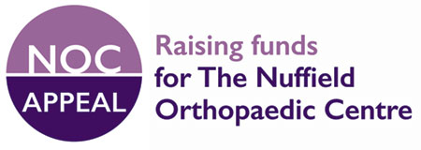

Nuffield Orthopaedic Centre Charity, also known as the Nuffield Orthopaedic Centre Appeal
Nuffield Orthopaedic Centre, Oxford University Hospitals NHS Foundation Trust
Windmill Road, Headington, Oxford OX3 7HE
Tel: 01865 227722 / 738000 and 07885 144 890
www.ouh.nhs.uk/nocappeal
Patron: Her Majesty The Queen

Legacy

I (Mr / Mrs / Miss / Ms [Title])

of:

I GIVE TO THE Trustees for the time being of the Nuffield Orthopaedic Centre Charity of the Nuffield Orthopaedic Centre, Windmill Road, Headington, Oxford OX3 7HE (Registered Charity No. 1006509)
the sum of
£ Words:
for the benefit of the Nuffield Orthopaedic Centre Charity and I DECLARE that the receipt of anyone purporting to be the Appeal Director or other proper officer of the said charity shall be a good discharge to my Trustees for this gift.
Note: this clause is intended to be part of your Will or embodied in a Codicil to it and you are strongly recommended to consult your Solicitor.

