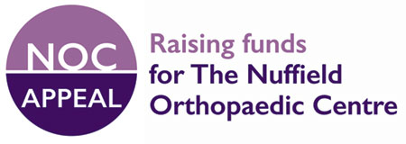

NOC Appeal standing order form
Nuffield Orthopaedic Centre, Oxford University Hospitals NHS Foundation Trust
Windmill Road, Headington, Oxford OX3 7HE
Tel: 01865 738000
www.ouh.nhs.uk/nocappeal
Patron: Her Majesty The Queen
To the Manager
Bank / Building Society:
Address:
Post code:
Please pay for the Credit of the Nuffield Orthopaedic Centre Appeal at:
NatWest, High Street, Oxford OX1 4DD
Account number 86151398
Sort code 60-70-03
Each *month / quarter / year / single payment* (until you receive further notice from me in writing) * (Delete as appropriate)
The sum of £
Amount in figures: Amount in words:
Start date:
Name:
Address:
Signature: Date:
Bank sort code:
Bank account number:

Gift Aid declaration
If you are a UK taxpayer this means that we can reclaim tax that you have already paid on your donation. That is worth 25p for every £1 you give. All you need to do is to tick the box below.
[ ] Yes, I pay tax in the UK, and want my donations treated as Gift Aid

Please return this form to:
Appeal Director, NOC Appeal Nuffield Orthopaedic Centre FREEPOST, Headington, Oxford OX3 7HE

